**IKEA MALM**

**Assembly Manual**

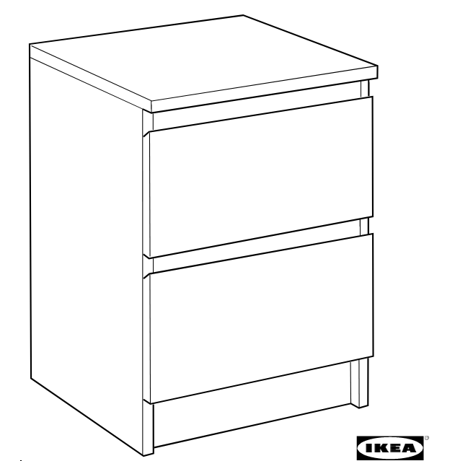

*This is your IKEA MALM two-drawer chest assembly manual. Thank you for purchasing IKEA.*

Contents:

Preparing your workspace 3

Assembly Kit Contents 3

Assembly Instructions 4

Assembling the sides 4

Assembling the top 4

Installing the back cover 4

Assembling the drawers 5

Installing the drawer rails 5

Done 5

|  |  |  |
| --- | --- | --- |
| © Inter IKEA Systems B.V. 2022 | 21.10.2022 |  |

# Preparing your workspace

In order to assemble the chest in a fast and safe manner, it is recommended that you prepare your workspace. Please ensure that you have sufficient space to place the parts of the kit, a clean and stable flat surface to put the details together, and a place to keep your tools.

|  |
| --- |
| **Tip**: Never assemble anything directly on the ground. Always cover your working surface to prevent damaging or soiling. |

|  |
| --- |
| **Tip**: You can use a carpet or the package cardboard to cover the floor. |

For assembling the chest, you will need the following tools:

* flat-head screwdriver
* cross-head screwdriver
* pencil
* hammer.

|  |
| --- |
| **Tip**: It is advised that you work together with another person, who can read the instructions for you. |

In case of unclear instructions, do not hesitate to call your local IKEA customer support office for help.

# Assembly Kit Contents

The assembly pack contains:

|  |  |  |
| --- | --- | --- |
| **Item** | **Description** | **Quantity** |
| Bolt #110519 | A bolt, with a carved bottom part and a wide flat head without a screwdriver hole. | 8 |
| Bolt #118331 | A bolt, consisting of two parts: a carver bottom part and an upper part, which acts as a pin. The bolt has a cross-head screwdriver hole. | 20 |
| Pin #101345 | A wooden pin, used to hold two parts together. Stick each end into the corresponding hole of each part you want to join. | 20 |
| Locking bolt #120076/119030 | A wide short bolt, used to lock another bolt from unscrewing. It has a flat-head screwdriver hole. | 20 |
| Bolt #100365 | A small short fully-carved bolt with a tiny cross-head screwdriver hole. | 12 |
| Bolt #115339 | A small very short flat-head fully-carved bolt. | 4 |
| Nails #101221 | A bag of nails. Install them with a hammer. | 1 bag |
| Chest legs #102372 | Each leg is a flat piece with two pins. | 4 |
| Drawer rails (pair) | The rails to be installed on the drawers. The corresponding bearing rails are already installed on the chest sides. | 2 |

# Assembly Instructions

## Assembling the sides

|  |
| --- |
| **Tip**: The chest is completely symmetric by design. Therefore, it is recommended that you work in a symmetric manner. The actions for both sides of the chest are identical. |

1. Place each sideboard next to each other, the pre-installed drawer rails facing upwards. The wheel of each rail should be on the left (right) side of the left (right) sideboard.
2. Place 4 bolts #118331 on each sideboard in the following manner: one in each upper hole of the three left (right) pairs of holes of the left (right) sideboard. Then one bolt in the left (right) hole of the remaining pair. Screw them in, until their carved parts are no longer visible. Now the bolts would act as metal pins.

|  |
| --- |
| **Tip**: Do not screw the bolts too much. You can always tighten them later, in case they are to loose. In this, damaging the parts when screwing is less likely and unscrewing is easier, if you make a mistake. |

1. Stick each leg leg #102372 into the pairs of holes on the bottom edge of each sideboard.
2. Fit each of the four connecting laths with a pin #101345, so that each pin matches the empty holes of each sideboard and the metal bolts (acting as pins) of the sideboards enter each unused hole of each lath. Put and fix all laths on one of the sideboards (e.g the left one).

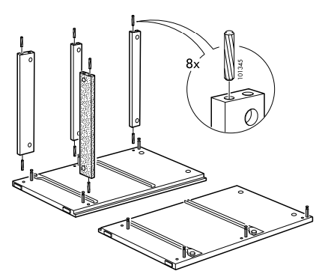

1. The openings for the locking bolts of each lath must be in the interior of the chest, when assembled.
2. Fit and screw locking bolts #120076/119030 in the above-mentioned holes in order to immobilize the connecting laths.
3. Now flip the other sideboard and fix it to the laths
4. Flip the chest rightwards, it’s front facing downwards and the three laths facing upwards.
5. Screw the remaining 4 locking bolts #120076/119030 of the laths.

## Assembling the top

1. Flip the chest, so that it stands on its legs.
2. Place 4 bolts #118311 on the top board, one in each pair of holes of the top.
3. Place 1 pin #101345 in one hole of all four pairs of holes, located on the sideboards’ upper edge. Each pin should match an empty hole of the top board and each bolt of the top board should match an empty hole on the sideboards’ upper edge
4. Place the top over the pins and press to put it in place.
5. Immobilize the top by screwing 4 locking bolts #120076/119030 in the wide holes inside the chest (on the sideboards).

## Installing the back cover

1. Flip the chest. It’s front should be facing the floor and its back should be facing upwards.
2. Place the back cover on the back of the chest.
3. Hammer in all 30 nails on equal distance from each other.

|  |
| --- |
| **Tip**: Start with the four corners. Then place a nail in the middle of each two corner nails. Then place a nail between all two nails, etc., until you cover the whole perimeter. |

## Assembling the drawers

1. Start by placing the front board of the drawer horizontally, the sloping edge and holes facing upwards, towards you.
2. Place one bolt #118331 in each pair of holes of the front board. Screw the bolts
3. Place one pin #101345 in each pair of holes in the drawer sideboards.
4. Each bolt #118331 on the drawer front board should match an empty hole in the drawer’s sideboard. Each pin #101345 on a drawer sideboard should match a bolt #118331 on the drawer front board.
5. Fix the sideboards of the drawer to its front board.
6. Use locking bolts #120076/119030 to fix the sides to the front permanently.
7. Slide the bottom of the drawer into its channel. Notice the channel of the front board. It is meant to fit the drawer bottom.
8. Insert the back of the drawer into its place. Notice the channel carved into it. It is meant to match with the drawer bottom. In this way, the drawer bottom is supported by the sides, the front and the bottom of the drawer.
9. Screw two bolts #110519 in the holes of each drawer sideboard to fix the back of the drawer to its sides.
10. Screw two bolts #115339 into the two holes on the back surface of the drawer front. They will keep the front fixed to the sideboards.
11. Repeat steps 1-11 for the other drawer.

## Installing the drawer rails

1. Flip the drawer upside down. Its bottom should be facing upwards.
2. Place two rails on each side of the drawer.
3. Fix them with bolts #100365, one on each side of a rail.
4. Repeat for the other drawer.
5. Flip the drawers back in normal position and slide them into their slots inside the chest.
6. If you have worked properly, the sloped edge of each drawer front board should be facing upwards when the drawers are inside the chest.

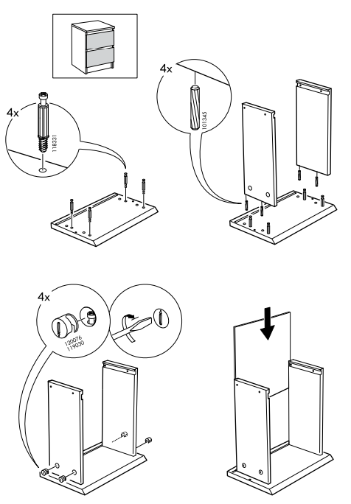

# Done

You are now ready to use your IKEA MALM two-drawer chest. Visit IKEA again for even more amazing home accessories!